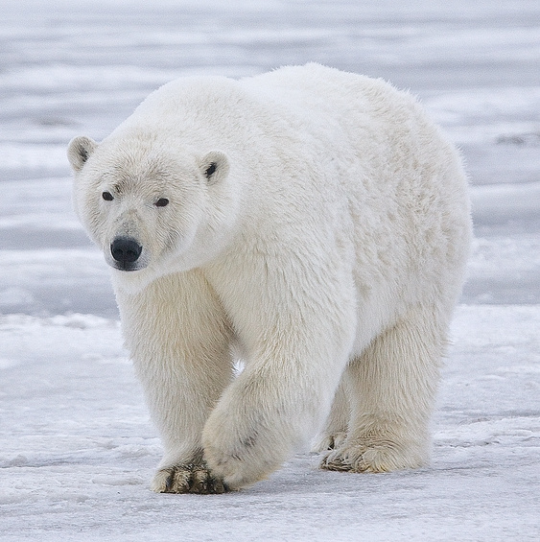
Paigitsiaguk - Take Care of It
Nanuk Video One: Paninnguaq’s Story
Visit Torngat Secretariat
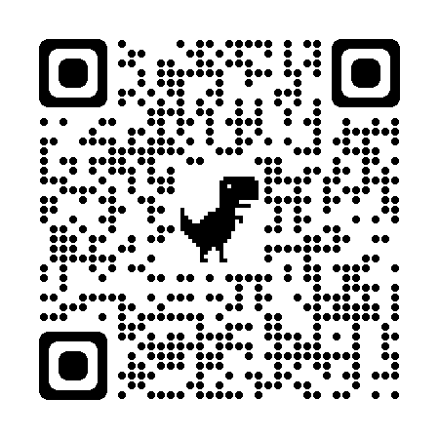
Grade Level: 4-6 Subjects: Art and Social Studies
Duration: 2 hours
Background:
Prehistoric Inuit shared a profound spiritual connection with polar bears, but many contemporary Inuit struggle to form such connections. Climate and lifestyle changes have reduced the reliance on polar bears for survival, resulting in fewer opportunities for today's Inuit to create spiritual and cultural bonds with these magnificent creatures. Students are encouraged to explore and express their spiritual and cultural connection to an animal or fish using watercolour paint.
Guiding Question(s)
- How have pre-historic Inuit made connections with Nanuk?
- Do you have a connection with any animals or fish?
- Think about what “spirit animal” suits you. Think about what attributes of that animal you relate to.
Learning Activity:

Nanuk videos Watch video #1
- Have a discussion about spirit animals and ask students if they can think of an animal that they share a strong connection with. A spirit animal refers to an animal spirit which helps guide or protect a person through life’s journey and whose characteristics that person shares or embodies.
- Watch the YouTube video titled, “Arctic Polar Bear Water Colour Painting Tutorial” (3:25) to learn some water colour techniques.
- Students are tasked with creating a visual representation of their personal spirit animal, emphasizing the elements that contribute to their connection with it.
Evaluation:
Participation and completion of the spirit animal water colour activity.
Resources/Materials
- Watercolour paper and paint
- Water containers
- paint brushes
- Paper Towel
- Youtube video titled, “Arctic Polar Bear Water Colour Painting Tutorial” (3:25) https://youtu.be/6vILOa2T8GQ?si=FiB93M2VSIngHBvale
Language
Polar Bear - Nanuk
NLESD Curriculum Connections:
Art Curriculum Kindergarten-Grade 12
Blackline Masters:
Examples of water colour art for students to look at

